Computer Language Coding Concepts

Object Inheritance
An object can merge with another object, delegating its interface, implementation and its values to another object:

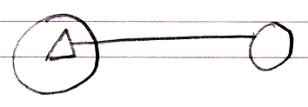

So this time the interface has an object line. This means that as soon as the other object’s values change, the derived object is automatically also changed. The other way around is also true: when you change the derived object’s inherited members, the base object also changes. Changes are not applied from one to the other: both are just references to exactly the same object.

Author & Copyright: Jan-Joost van Zon Date: May 18, 2010 – July 17, 2010 Location: Oosterhout, The Netherlands Status: Finished

